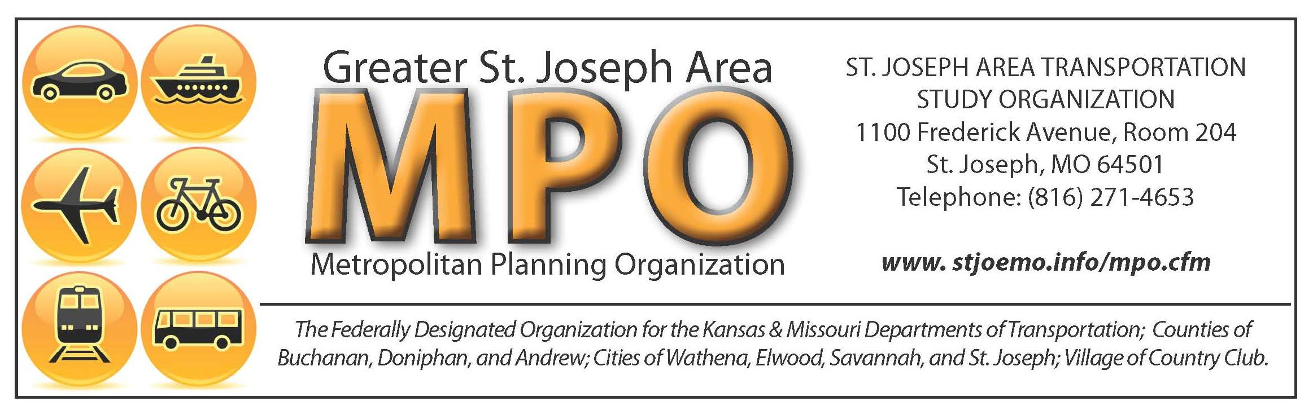

Agenda
Coordinating Committee Meeting

DATE: Thursday, April 17th, 2025
TIME: 12:00 p.m. to 1:00 p.m.
- LOCATION: St. Joseph City Hall, 1st floor conference room

- OPENING REPORTS
A. | Roll Call of Voting Members
B. | Approval of Minutes from Prior Meeting: December 12th, 2024
- NEW BUSINESS
- MPO update
Action Needed: None
- 2025 Public Participation Plan (PPP)
Action Needed: Vote
- 2026 Unified Planning Work Program (UPWP)
Action Needed: Vote
- 2026-2029 TIP First Look
Action Needed: None

- MISCELLANEOUS
- Opportunity for Public Comment
- Next Meeting: June 19th, 2025, 12:00 – 1:00 –TBD

OTHER/ADJORNMENT
SJATSO fully complies with Title VI of the Civil Rights Act of 1964 and related statues and regulations in all programs and activities. For more information or to obtain a Title VI Complaint Form please visit https://stjosephmo.gov/1004/Title-VI or call (816) 236-1471

ST. JOSEPH AREA TRANSPORTATION STUDY
COORDINATING COMMITTEE
4th Floor Conference room – City Hall – St. Joseph
12:00 to 1:00 – December 12, 2024

Voting members present:
Royal Turner Committee Chair
John Josendale St. Joseph City Mayor
Madison Davis St. Joseph City Council Member
Clint Thompson St. Joseph City Manager
Ron Hook Buchanan County Commissioner
Ashley Albers Village of Country Club Representative
Bruce Lundy City of Savannah Administrator

Voting members not present:
Marty Novak St. Joseph City Council Member

Staff members present:
Max Schieber City of St. Joseph
Jackson Lohman City of St. Joseph
Abe Forney City of St. Joseph
Ashley Parker City of St. Joseph
Chance Gallagher City of St. Joseph

Others present:
Adam Wood MoDOT
Tom Brand Community Alliance

OPENING REPORTS
- Roll Call. A quorum was present. Royal Turner called the meeting to order.

- Approve the minutes of the prior meeting. Madison Davis motioned to approve the minutes from the October 17th, 2024 meeting, and Ashley Albers seconded. By general consent, the prior meeting minutes were unanimously approved.

NEW BUSINESS
A. MoDOT State System Performance Targets and MoDOT Statewide Pavement and Bridge Targets
A summary of performance targets was presented, including travel time reliability percentages for both interstate and non-interstate systems, as well as freight reliability measures. The 2025 baseline targets are slightly lower than in previous years due to ongoing construction and maintenance work along key highway and bridge corridors. Pavement and bridge condition targets were also shared, detailing the percentage of infrastructure in good or poor condition. While the MPO has the option to adopt its own targets, the committee elected to support the existing targets set by MoDOT and KDOT. Madison Davis moved to approve the performance measures, with John Josendale seconding. By general consent, the MoDOT State System Performance Targets and MoDOT Statewide Pavement and Bridge Targets were unanimously approved.
- Title VI Update: The Title VI plan is federally required data done by the MPO for the region. The maps, numbers, figures, and tables have all been updated, along with newly added information. The data includes the region's population, elderly, those with disabilities, residents without vehicles, and race. The data will not be 100% accurate, as not everyone fills out a census. The Title VI plan also allows residents to file complaints against discrimination, which will be sent to Chance Gallagher, the Deputy Director of Public Works and Transportation. John Josendale motioned to approve the Title VI update and Ron Hook seconded the motion. By general consent, the Title VI update was unanimously approved.

- 2025 UPWP: This UPWP will cover just 6 months of funds, to better align the MPO with the City and State FY and then in June of 2025 another UPWP will be adopted for the remainder of the FY2025 funds. The funds will include $117,656.00 in CPG funds, and $29,414.00 in local funds, for a total of $147,070.00. The UPWP describes the proposed activities during the fiscal year. The program is prepared annually, usually from Jan 1- June 30th, but to align with the state, this 6-month document will expire and a new UPWP will run through July 1- June 31st. The UPWP also pays the salaries of the MPO Transportation Planners. Madison Davis motioned to approve the 2025 UPWP and Ashley Albers seconded the motion. By general consent, the UPWP was unanimously approved.

- 2050 MTP: The SJATSO 2050 Metropolitan Transportation Plan (MTP) is the official document outlining the transportation vision for the SJATSO metropolitan planning area. This Ron Hook motioned to approve the 2050 MTP and Madison Davis seconded the motion. By general consent, the MTP was unanimously approved.

- 2025 Coordinating Committee Schedule: Informational.

MISCELLANEOUS
Other Items: None.

Next Meeting: February 20th, 2025, 12:00 pm-1:00 pm- Fourth Floor Conference Room, City Hall.

OTHER/ ADJOURNMENT
With no other comments and items on the agenda, John Josendale motioned to adjourn and Ashley Albers seconded the motion. With general consent, the meeting was adjourned.

