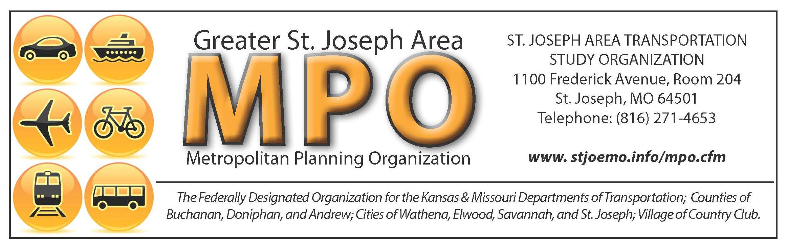

Agenda
Technical Committee Meeting

DATE: Thursday, May 16th, 2024
TIME: 10:30 to Noon
- LOCATION: St. Joseph City Hall, 1st floor conference room

- OPENING REPORTS
A. | Roll Call of Voting Members
B. | Approval of Minutes from November 16th, 2023, and Joint Committee meeting April 18th, 2024,
- NEW BUSINESS
- 2025-2028 TIP
Action Needed: Vote
- KDOT Carbon Reduction Grant FYI
No Action Needed

- MISCELLANEOUS
- Next Meeting: July 18th 10:30-12:00 - Location TBD

OTHER/ADJORNMENT
SJATSO fully complies with Title VI of the Civil Rights Act of 1964 and related statues and regulations in all programs and activities. For more information or to obtain a Title VI Complaint Form please visit https://stjosephmo.gov/1004/Title-VI or call (816) 236-1471

ST. JOSEPH AREA TRANSPORTATION STUDY

Technical Committee

City Hall, St. Joseph, MO

November 16, 2023

Voting Members Present:
Julius Rice City of St. Joseph, Chairperson
Phillip Leimbach City of St. Joseph, Vice Chairperson
Max Schieber SJATSO/MPO Staff
Joshua Stephens SJATSO/ MPO Staff
Chance Gallagher City of St. Joseph

Abe Forney City of St. Joseph

Scott Gatewood City of St. Joseph

Mike Henderson MoDOT

Adam Wood MoDOT

Other:

Dave Earls MoDOT

OPENING REPORTS

- Roll Call of Voting Members: A quorum was present. Chairperson, Julius Rice called the meeting to order at 10:30 am.

- Approval of Minutes from October 19, 2023 meeting: Abe Forney motioned to approve the October 19th meeting minutes and Chance Gallagher seconded the motion. By general consent, the meeting minutes were unanimously approved.

NEW BUSINESS

A. FY24 UPWP: Max Schieber gave a brief update on the Unified Planning Work Program (UPWP) with the total amount of funding of $335,632.00. The UPWP is a description of the proposed activities of SJATSO detailing transportation planning, programs, and activities to be performed in the metropolitan planning area during the fiscal year 2024 (January 1, 2024 – December 31, 2024). This program is prepared annually and provides a foundation for the request of federal planning funds from the U.S. Department of Transportation (USDOT) through the Missouri and Kansas DOTs. Chance Gallagher motioned to approve the FY 2024 UPWP and Abe Forney seconded the motion. By general consent, the UPWP was unanimously approved.

- 2024-2027 TIP Amendment II: St. Joseph Transit has requested to add three (3) projects in the Public Transit section of the TIP and amend one (1) project. The City of St. Joseph has requested to add one (1) project to the Bicycle and Pedestrian section. The Village of Country Club has requested adding one (1) project to the Bicycle and Pedestrian section. Finally, the City of Savannah has requested to amend one (1) project in the Bicycle and Pedestrian section. Chance Gallagher motioned to approve the TIP Amendment II and Phil Leimbach seconded the motion. By general consent, the TIP Amendment was unanimously approved.

- MoDOT Safety Update: Adam Wood with MoDOT, gave a brief update on some safety changes being made to a few intersections in the coming years. One safety update is the interchange at Rte. 169 and FF in 2026 with added truck aprons and the other is the 71 HWY southbound onramp to I29 to better manage visibility and flow of traffic. Informational.

- TAP FYI: Max Scheiber informed the Committee that TAP funds in the amount of $500,000.00 have been approved for the Cook Road Safe Routes to School Project and $414,000.00 have been approved for the Country Club Trail Project. Informational.

- 2024 Meeting Schedule: Meeting dates were given to the Committee members with locations to be discussed at a later date. Informational.

MISCELLANEOUS
- Opportunity for public comments and questions. None.

Next Meeting: January 16th, 2024, 10:30-12:00- Country Club Community Hall

ADJOURN: Scott Gatewood motioned to adjourn the meeting and Abe Forney seconded the motion. The meeting was adjourned.

ST. JOSEPH AREA TRANSPORTATION STUDY
JOINT TECHNICAL & COORDINATING COMMITTEE
Conference Room- St. Joseph Convention and Visitors Bureau- St. Joseph
12:00 to 1:30 – April 18, 2024

Technical voting members present:
Julius Rice City of St. Joseph, Chairperson
Phillip Leimbach City of St. Joseph, Vice Chairperson
Chance Gallagher City of St. Joseph
Abe Forney City of St. Joseph
Joshua Stephens City of St. Joseph/ MPO
Max Schieber City of St. Joseph/ MPO
Jose Rodriguez MoDOT-NW
Adam Wood MoDOT-NW

Coordinating voting members present:
John Josendale St. Joseph City Mayor
Bryan Carter St. Joseph City Manager
Ron Hook Buchanan County Commissioner
Royal Turner Citizen Representative

Staff members present:
Ashley Parker City of St. Joseph
Michelle Schultz City of St. Joseph/ Transit
Cecelie Cochran Federal Highway Administration
Kevin Irving Federal Highway Administration

OPENING REPORTS
- Roll Call. A quorum was present for the Technical Committee and Coordinating Committee. Ron Hook called the meeting to order.

NEW BUSINESS

- Metropolitan Transportation Plan Presentation and Discussion: Jim Meyers with AECOM presented the Technical and Coordinating Committee with the 2050 Project update. The update included the project schedule, 2045 MTP needs, existing conditions, and potential multimodal projects. This MTP Project Plan will be adopted in November 2024. Discussions included roadway/freight needs, transit needs, and bike/ped needs. Safety conditions were also discussed, Jim explained about fatality and serious injury crashes, crash densities, crash types, bike/ped safety and the traffic volume that ties to these statistics. Cook Road and US 169 Intersection was discussed to be added as a potential project if it hasn’t been added previously. No Action Needed.

MISCELLANEOUS

Other Items: Opportunity for Public Comment.

Next Meeting: Technical Committee- May 16th, 2024- 10:30 am-12:00 pm- First Floor Conference Room-City Hall
Coordinating Committee- June 20th, 2024- 12:00 pm-1:00 pm- City Hall, 4th Floor Conference Room.

OTHER/ ADJOURNMENT

With no other comments and items on the agenda, Ron Hook motioned to adjourn the joint meeting. With general consent, the meeting was adjourned.

